A12 - User Manual

Year: _2025_____ Semester: __Spring______ Team: __9___ Project:______FairwayFinder____

Creation Date: ___4/15/25________ Last Modified: April 19, 2025

Author: _______Liam Kauffman______ Email: ___wkauffma@purdu.edu_______

Assignment Evaluation: See the Rubric in the Brightspace Assignment

Product Description

Welcome to the future of golfing convenience with the FairwayFinder! Carrying a heavy golf bag over 18 holes can be strenuous, detracting from the enjoyment of the game. The FairwayFinder is designed to eliminate this burden. It is a compact, autonomous robotic caddy engineered to securely carry your golf bag and clubs, automatically following you throughout your entire round.

The FairwayFinder stays with you on the course by leveraging bluetooth communication, gps tracking, and intelligent navigation algorithms. Its chassis is built to handle typical golf course terrain and carry a standard, fully loaded golf bag (up to 50 lbs). The high-capacity rechargeable battery system ensures the FairwayFinder has ample power to last a half a round (designed for 4+ miles of operation).
The FairwayFinder offers flexible operation modes:
- Autonomous Following: Simply activate the follow mode, and the robot will track your position and maintain a consistent distance.
- Remote Control: Use the dedicated mobile application to manually steer the FairwayFinder when desired.
- Manual Operation: Physical controls allow for direct, manual maneuvering of the robot if needed.

Product Illustrations

Robot Chassis: Battery Switch:

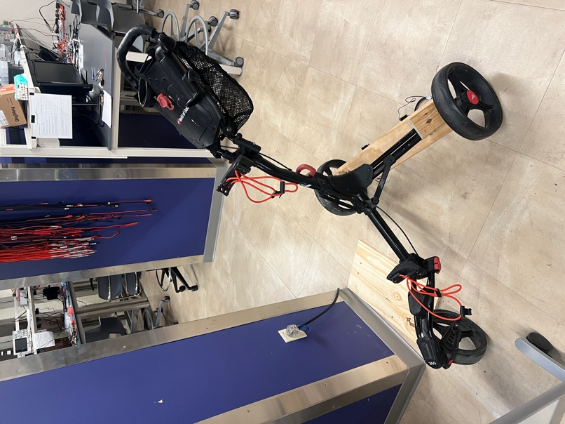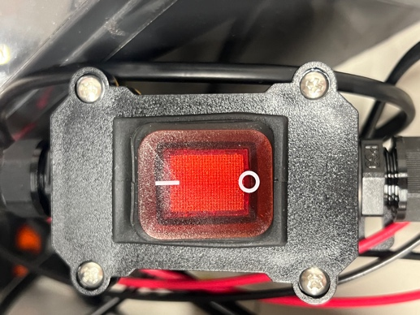

FairwayFinder App:

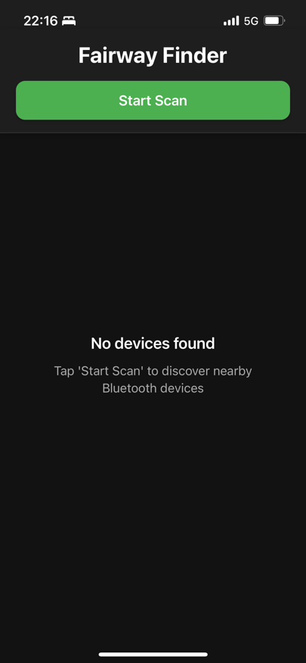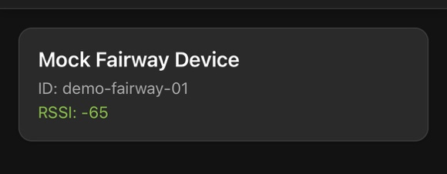

App Follow me and Manual Modes:

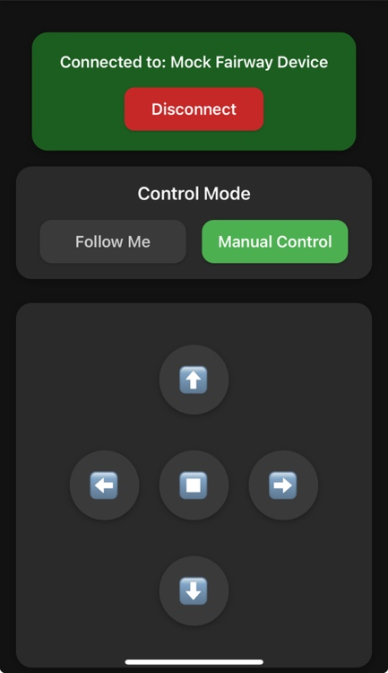
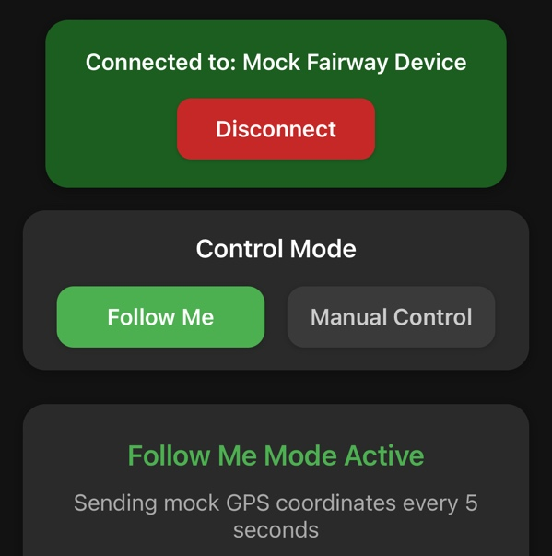

Setup Instructions
Follow these steps carefully to prepare your FairwayFinder for use. Refer to the Product Illustrations in Section 2.0 as needed.
3.1 Initial Unpacking and Component Check:
- Carefully remove all components from the packaging.
- Verify that you have received all items:
  - FairwayFinder Robotic Caddy Unit
  - Rechargeable Battery Pack
  - Battery Charging Adapter
  - User Manual (this document)
- If any items are missing or damaged, please contact customer support (See Section 5.0 Troubleshooting).
3.2 Charging the FairwayFinder Robot Battery:
4. Locate the Battery Charging Port on the rear of the FairwayFinder unit
5. Connect the charger connector of the charging adapter unit to the FairwayFinder's charging Port
6. Plug the charging adapter's AC power cord into a standard electrical wall outlet.

7. The charging status indicator LED on the charging adapter will illuminate to indicate charging is in progress.
8. Allow the battery to charge fully. A full charge typically takes approximately 1 hour.
9. Once the charging status Indicator LED indicates a full charge, unplug the charging adapter from the wall outlet first, then disconnect it from the FairwayFinder.
3.3 Installing and Connecting the Mobile Application
10. On your smartphone (iOS or Android), navigate to the App Store or Google Play Store.
11. Search for and download the official "FairwayFinder" app
12. Ensure Bluetooth is enabled on your smartphone within its settings menu.
13. Launch the FairwayFinder Control app.
14. Follow the on-screen instructions within the app to scan for and connect to your FairwayFinder unit.
15. Once connected, the app should display a "Connected" status indicator.
3.4 Attaching Your Golf Bag
16. Position your golf bag onto the Golf Bag Holder (B) on the FairwayFinder (Figure 2.1).
17. Secure the golf bag firmly using the integrated straps/clamps (Note: Specify the securing mechanism). Ensure the bag is stable and will not shift during movement. Check that the bag does not obstruct any sensors (D, J).

Usage Instructions
This section details the regular operation of your FairwayFinder after completing the initial setup (Section 3.0). Please follow these steps for a smooth experience on the golf course. Refer to the Product Illustrations in Section 2.0 as needed.
4.1 Preparing for Use
- Ensure the FairwayFinder main battery is adequately charged (Section 3.2).
- Ensure your smartphone is charged and has the FairwayFinder Control app installed (Section 3.3).
- Ensure your golf bag is securely attached to the FairwayFinder (Section 3.6).
- Place the FairwayFinder near your starting position.
4.2 Powering On and Connecting via App
5. Locate the main battery switch on the FairwayFinder unit {Section 2 image). Turn the switch to the 'ON' position.
6. The System Status Indicator LEDs should illuminate, indicating the unit is powered on.
7. Enable Bluetooth on your smartphone (refer to your phone's operating instructions).
8. Open the FairwayFinder Control app on your smartphone.
9. Tap the "Scan for Devices" button within the app.
10. Fairway device will appear. Select your device, typically named "Fairway".
11. Once the connection is established, the app will display the main status screen, showing connection status and battery level.
4.3 Selecting an Operating Mode
12. From the app's main screen, choose your desired operating mode:
Follow Me Mode: Select this option for autonomous following.
Manual Mode: Select this option to control the robot directly via the app.
4.4 Operating in "Follow Me" Mode (This mode uses your connected smartphone's location/signal for tracking) 1
13. Ensure "Follow Me Mode" is selected in the app.
14. Keep your smartphone on your person (e.g., in a pocket). For best performance, try to maintain a relatively unobstructed path between your phone and the FairwayFinder. 1
15. Begin walking. The FairwayFinder will attempt to follow you, maintaining a predetermined distance.
4.5 Operating in "Manual Mode" via App
16. Select "Manual Mode" in the app. This will typically bring up the manual control interface
17. Use the directional buttons within the app to drive the FairwayFinder:
Forward Button: Moves the robot forward.
Left Button: Turns the robot left.
Right Button: Turns the robot right.
Backward Button: Moves the robot backward.
Center Button: Applies the brake, stopping the robot.
18. To exit Manual Mode, navigate back to the app's main screen (e.g., using button CC) and select a different mode or disconnect.
4.6 Disconnecting for Manual Pushing
19. If you need or want to push the FairwayFinder manually,
1) Ensure the robot is stopped (use the Center/Brake button in Manual Mode if connected)
2) Disconnect the FairwayFinder from the app (use a "Disconnect" button in the app settings or main screen).
3) Turn the main Battery Switch to the 'OFF' position. * You should now be able to push the cart manually.

Troubleshooting Instructions

Problem | Potential Causes | Solutions
FairwayFinder robot does not power ON. | 1. Battery is completely discharged.  2. Battery not properly connected (if user-removable).  3. Internal electrical fault. | 1. Charge the main robot battery fully using the provided charger (Section 3.2). Verify charging indicator shows charging is active.  2. Ensure battery pack is securely seated in its compartment  3. If problem persists after full charge, contact customer support.
Robot battery does not seem to charge. | 1. Charger not securely plugged into wall outlet or robot charging port  2. Wall outlet is not live.  3. Charging port or charger connector is dirty or damaged  4. Faulty charging adapter or battery pack. | 1. Double-check all connections: charger to wall, charger to robot.  2. Test the wall outlet with another device.  3. Inspect port and connector for debris or bent pins. Clean gently with dry air or a soft brush if needed.  4. If possible, test charger with another compatible device. If charging still fails, contact customer support.
App and robot do not pair/connect. | 1. Devices are too far apart during pairing attempt.  2. One or both devices not powered ON.  3. Significant Bluetooth interference nearby.  4. Pairing procedure not followed.  5. Low battery charge on one or both devices.  6. Bluetooth disabled on smartphone | 1. Ensure beacon is within 1-2 meters (3-6 feet) of the robot during power-on/pairing.  2. Verify both units are ON (check Status LEDs F & L).  3. Move away from other strong wireless sources. Power cycle both devices and try again.  4. Ensure both devices have adequate charge.  5.Charge both devices  6. Enable Bluetooth on phone device
Robot follows erratically or stops frequently. | 1. Intermittent obstruction of robot.  2. User moving too quickly, especially around sharp corners.  3. Very uneven or steep terrain challenging the robot's navigation/stability.  4. Low battery level on robot or beacon affecting performance. | 1. Adjust phone positioning to improvesignal  2. Maintain a steadier pace, especially when turning.  3.Try operating in a different area if interference is suspected.  4.Check battery levels via app (V); charge units if low.
Mobile App or Physical controls are unresponsive. | 1. Robot is OFF or app is not connected (for app control).  2. Correct manual control mode is not engaged.  3. Robot battery level is critically low. | 1. Verify robot power and app connection status.  2. Ensure you have correctly switched to App Manual Control  3. Check battery level, charge immediately if critical. Restart the mobile app. Power cycle the FairwayFinder robot. Check for firmware updates.
FairwayFinder makes unusual noises. | 1. Debris caught in wheels or drive mechanism.  2. Loose component  3. Internal motor or gearbox issue. | 1. Power OFF the robot. Inspect wheels and axles for tangled grass, stones, or other debris. Remove carefully.  2. If noise persists and sounds internal (grinding, clicking), discontinue use and contact customer support.
If you have tried the relevant troubleshooting steps above and are still experiencing issues with your FairwayFinder, please contact our support team for assistance:
- Website: www.FairwayFinderRobotics.com/support
- Email: help@fairwayfinder.com
- Phone: 1-800-GOLF-BOT (1-800-465-3268)

